**ABOUT THE COMPANY**

* 1. Introduction
  2. Vission, and Mission
  3. Products and Services
  4. Tasks Performed
  5. Conclusion

**1.1 Introduction / brief history:**

Jai Engineering Works is a well-established manufacturing company based in Chennai, India, specializing in precision-engineered components and turned parts. The company has a strong track record in delivering high-quality products and services to various industries, including automotive, machinery, and manufacturing

**1.2 Vission and Mission**

Precision metal cutting operations involving turning,milling,grinding,honing,heat treatment,coating as per print.Turned parts, machined parts, CNC turned parts, precision turned parts with secondary operations like milling and drilling, turned parts with heat treatment, sliding head turned parts.A variety fo raw materials-steel turned parts, aluminium turned parts, brass turned parts etc﻿

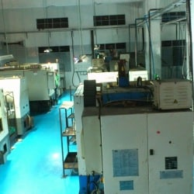

**1.3 Products And Services**

Turned parts like sleeves, adapters, capnuts, nuts, injector screws, fuel injection parts, cam rings,piston, secondary piston, banjo bolts,precision steel rivets, machining of SG iron castings like engine mounting brackets, knuckle, differential, pressure plates, flywheel, machining of ferrous and non ferrous forgings are undertaken.

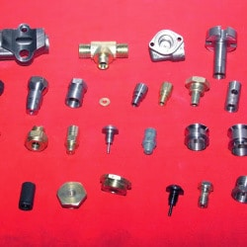

Parts made from single spindle auto lathes, sliding head auto lathes, swiss turning lathes etc are undertaken by us. Free cutting steel like EN1A, 9SMnPb28, medium carbon free cutting steel like EN8M, C45,S45C,EN8D are used extensively and many parts have heat treatment and other finishing operations.Aluminium extrusion profiles from 6061, 6063, 6082 in T6 condition are used

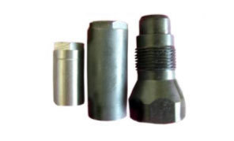

As suppliers of of precision machining parts to the fuel injection industry we are capable of supplying parts with bore tolerances of less than 3 microns. Tandem bores, slotted bores can also be finished with high degree of accuracy.

We undertake ID Hex broaching in precision turned parts. ID hexagon sockets/square sockets

**1.4 Tasks Performed**

Turned parts like sleeves, adapters, capnuts, nuts, injector screws, fuel injection parts, cam rings,piston, secondary piston, banjo bolts,precision steel rivets, machining of SG iron castings like engine mounting brackets, knuckle, differential, pressure plates, flywheel, machining of ferrous and non ferrous forgings are undertaken**.**

Precision metal cutting operations involving turning,milling,grinding,honing,heat treatment,coating as per print.Turned parts, machined parts, CNC turned parts, precision turned parts with secondary operations like milling and drilling, turned parts with heat treatment, sliding head turned parts.A variety fo raw materials-steel turned parts, aluminium turned parts, brass turned parts etc﻿

As suppliers of of precision machining parts to the fuel injection industry we are capable of supplying parts with bore tolerances of less than 3 microns. Tandem bores, slotted bores can also be finished with high degree of accuracy.We undertake ID Hex broaching in precision turned parts. ID hexagon sockets/square sockets .

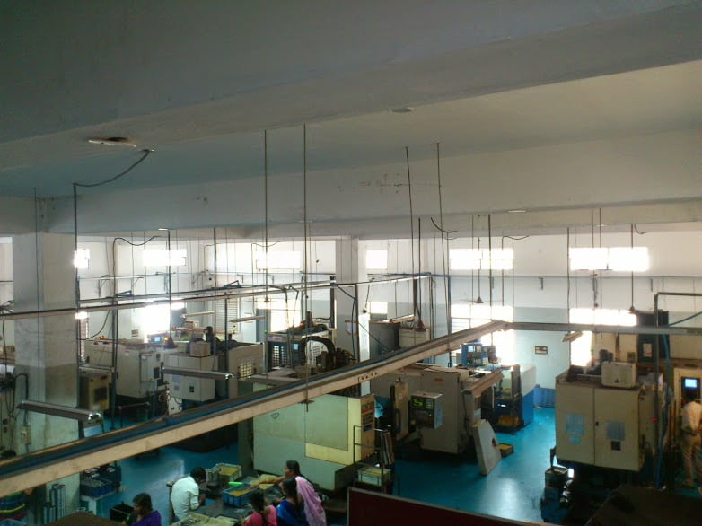

**1.5 Conlsion**

The internship at Jai Engineering Works has been an enriching and educational experience. It has provided a glimpse into a dynamic industry, an understanding of the importance of quality and precision, and the critical role of companies like Jai Engineering Works in meeting the demands of modern manufacturing. The insights and skills acquired during this internship will undoubtedly prove valuable in the future, and the experience will be remembered as a valuable step in the journey toward a career in the world of manufacturing .